**Lab :08**

**CLO 2**

**Rubrics:**

2 Marks for each first 4 tasks and 3 marks for each last 4 tasks.

**Topic: JOINS**

We can retrieve data from more than one tables using the JOIN statement. SQL Server has 4 types of joins:

* INNER JOIN/simple join
* LEFT OUTER JOIN/LEFT JOIN
* RIGHT OUTER JOIN/RIGHT JOIN
* FULL OUTER JOIN

INNER JOIN

This type of JOIN returns rows from all tables in which the join condition is true. It takes the following syntax:



We will use the following two tables to demonstrate this:

**Students Table:**

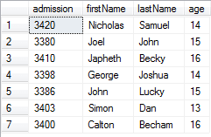

**Fee table:**

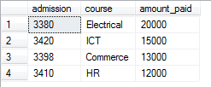

The following command demonstrates an INNER JOIN:



The command returns the following:

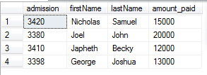

We can tell the students who have paid their fee. We used the column with common values in both tables, which is the admission column.

LEFT OUTER JOIN/Left Join

This type of join will return all rows from the left-hand table plus records in the right-hand table with matching values. For example:



The code returns the following:

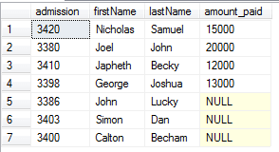

The records without matching values are replaced with NULLs in the respective columns.

RIGHT OUTER JOIN

This type of join returns all rows from the right-hand table and only those with matching values in the left-hand table. For example:



The statement returns the following:

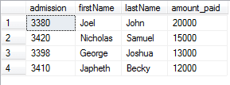

The reason for the above output is that all rows in the Fee table are available in the Students table when matched on the admission column.

FULL OUTER JOIN

This type of join returns all rows from both tables with NULL values where the JOIN condition is not true. For example:



The code returns the following result:

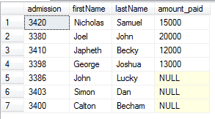

**Tasks:**

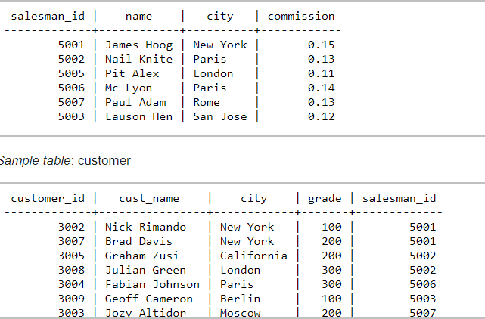

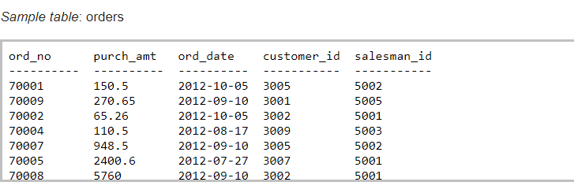

**Task 1:**

Write a SQL query to find the salesperson and customer who belongs to same city. Return Salesman name, cust_name and city.

**Task 2:**

Write a SQL query to find those orders where order amount exists between 500 and 2000. Return ord_no, purch_amt, cust_name, city.

**Task 3:**

Write a SQL query to find the salesperson(s) and the customer(s) he handle. Return Customer Name, city, Salesman, commission.  
**Task 4:**

From the following tables write a SQL query to find those salespersons who received a commission from the company more than 12%. Return Customer Name, customer city, Salesman, commission.

**Task 5:**

Write a SQL query to display the cust_name, customer city, grade, Salesman, salesman city.

**Task 6:**

 Write a SQL query to find those customers whose grade less than 300. Return cust_name, customer city, grade, Salesman, saleman city.

**Task 7:**

Write a SQL statement to make a list in ascending order for the salesmen who works either for one or more customer or not yet join under any of the customers.

**Task 8:**

Write a SQL statement to make a report with customer name, city, order no., order date, purchase amount for those customers from the existing list who placed one or more orders or which order(s) have been placed by the customer who is not on the list.